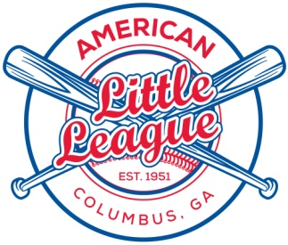

EIGHTH DISTRICT – GEORGIA
P.O. BOX 55
FORTSON, GA 31808
(I.D. #310-08-01)
www.americanll.org

BANNER DONATION INVOICE

Sponsor Information:
Name of Sponsor: ______________________________
ATTN: (contact person): ______________________________
Address of Sponsor: ______________________________
______________________________

Phone Number: (_____)__________________
American Little League Agent: ______________________________

Description | Cost | Quantity | Total
New Banner Purchase (first time) | $250.00
Banner Renewal | $200.00
 |  | Total Amount Due:

In addition to the banners used at the ball fields, all Sponsors will receive their artwork displayed on www.americanlittleleague.org for 1 year. Please send your logo in an electronic format to americanllcols@gmail.com for this purpose.

American Little League Information:
Banner sold by (Individual): _______________________________
Phone Number(s): _______________________________

Team Name: ____________________________________

League (Circle One): Girls Softball A-League B-League C-League T-Ball

The children of Columbus American Little League thank you for your generous donation. The
Columbus American Little League of Columbus, Georgia is a chartered member of Little League
Baseball, Incorporated and is covered under its Federal Group Exemption no. 3158 as described in section 501 (c) (3) of the Internal Revenue Code, and as such your donation should be tax deductible in accordance with applicable provisions of the Internal Revenue Code.

Field Banner Order Form

SIGN IS 3’ X 6’ X 10 OZ VINYL, BANNER W/WHITE (OR OTHER IF REQUESTED) BACKGROUND

Description:

Additional Donation: $ ______________ American Little League - Cols, GA

Questions/Other Information:

American Little League Information:

Sold by (Contact): ____________________________

Team Name: ____________________________

League (Circle One): Girls Softball A-League B-League C-League T-Ball

